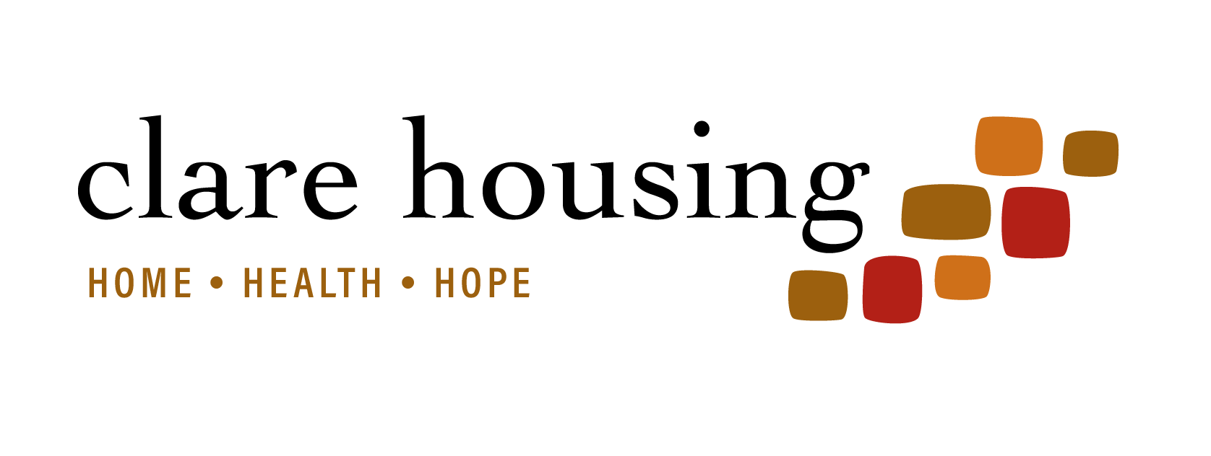

2020 Board Calendar

All meetings are from 4-6 p.m. at Clare Apartments unless otherwise noted.

Date | Agenda (subject to change/updates)
January 28  (no FC this month) | - Update on Executive Director Search
February 25  (FC – February 19) | - 2019 Health/Housing Outcomes Report  - Preliminary FY19 Year End Financials
March 24  (FC – March 18) | - Strategic Conversation
April 28  (FC – April 22) | - Strategic Conversation
May 19  (FC – May 13) | - FY2017 Audit/990 review/approval  - Strategic Conversation
June 23  (FC – June 17) | - TBD
July  (no FC this month) | - No July Meeting
August 25  (FC – August 19) | - Mid-year budget review/forecast (based on June 30 financials; review with FC at August meeting, bring to board for review/discussion)  - Launch Board recruitment for class of 2018
September 22  (FC – September 16) | - TBD
October 27  (FC – October 21) | - TBD
November 17  (FC – November 11) | - Board Elections  - Approval FY2018 Operating and Capital Budget  - FY21 Board calendar; yearend review; 2021 Operating Goals
December 8  (no FC this month) | - Holiday Social Gathering

